Encounters with the Abject: Kiki Smith’s Vulnerable Bodies

By Roxanne Runyon

Questions of embodiment have persisted as theoretical problems for feminist scholars. Often the site of violence – physical, textual, and representational – female bodies in particular have been marked by danger. Representations of women’s bodily function – menstruation, lactation, and pregnancy – have all been used to construct women as subjugated by their embodiment, and thus less capable of rational through. Shildrick notes that “Western ethics…makes transcendent disembodiment a condition of agency” (2), indicating that contemporary thought demands the body be overcome in order for an individual to truly achieve subjectivity. This kind of ontology has underpinned the oppression and social exclusions of women. This essay will explore how Kiki Smith has refused this ontology by producing sculptures that insist on a fully embodied agency.
Kiki Smith tells stories about bodies; stories that challenge how we as viewers think about our own corporeality and our own subjectivities. She depicts the most secret and sordid aspects of what it means to have a body; she makes visible the processes that we desperately try to keep hidden, the functions that we cannot control and the substances we produce that revolt us. These processes (such as urination, defecation, and menstruation) invoke shame and embarrassment: they can make us feel vulnerable and out of control. What does representing the body in this way do? What kinds of political or theoretical questions can this art speak to or be brought into conversation with? Kiki Smith represents the body in its most abject states, and by doing so, invokes feminist concerns about knowledge, the body, subjectivity and intersubjectivity. By pointing to the body’s inherent vulnerability and permeability, Smith’s work interrupts the dominant narratives of autonomous, self-contained subjectivity. She unsettles the ontology of the body, creating the possibility for new forms of knowledge rooted in the uncertainty and messiness of embodiment, and gestures to an intersubjectivity based in a mutual recognition of vulnerability.
In a careful analysis of four sculptures from 1990-1992 and one installation from 1986, I will read theory through Kiki Smith’s work. First, I will address why these depictions invoke feelings of disgust. What about them so we find so revolting? I will draw on Kristeva’s (1982) work on abjection in order to explore how these affects play a part in the constitution of our very subjectivities and how an encounter with Kiki Smith’s art might unsettle the boundaries of our own sense of self. I will then talk about the notion of bodily fluids and leakages; how making these visible might challenge dominant understandings of the body and of subjectivity. I am interested particularly in the political potential of representing the leaky female body and how fluids can exceed and deconstruct social categories. Leakiness and fluidity gesture to a certain kind of embodied vulnerability, an openness that goes against how we are taught to think about ourselves as subjects, and our bodies – especially in relation to other people. I will bring Kiki Smith’s art into conversation about vulnerability, ethics, and intersubjectivity.
Smith showed an interest in the human embodiment early on in her career. Indeed, Heartney writes that “Smith began her career deep inside the human body” (195), through depictions of internal organs and body parts. Having grown up with artistic parents – opera singer and actress Jane Lawrence Smith and noted minimalist sculptor Tony Smith – it is not surprising that Smith’s life and career have been dedicated to the creation of art, although the path that she has taken is somewhat less conventional (Heartney). After trying her hand at fashion design and industrial baking, she became involved with a New York art collective named Collaborative Projects, known as Colab, in the late 1970s. This group was dedicated to creating alternative spaces for art and resisting the commercial artworld by organizing exhibitions, film screenings, and performances that were accessible to a wider community. The members of Colab were committed to the integration of social, political, and personal questions in their art (Tallman). Smith’s first piece that featured representations of the body was a large bed-sheet printed with severed limbs, made for Colab’s Times Square Show in 1980 (Tallman). Over the years the scope of her bodily subject matter shifted from micro to macro. She produced simple and anatomically accurate sculptures of organs throughout the 1980s and began creating full figures in the 1990s. Posner writes that over a span of fifteen years, Smith was dedicated “to creating tender yet visceral depictions of the human body, both fragmented and whole” (44) to address the fundamental embodied nature of personal experience and social existence. Her political consciousness, nourished during her years working with Colab, continues to inform her work.
What is particularly notable about Kiki Smith’s work with the body is her refusal to depict bodies that conform to the dominant cultural fantasy of the body as a well-running machine, subordinate to the workings of the rational mind. Indeed, Smith interrupts this fantasy, the fantasy of le corps propre, one’s own clean and proper body (Kristeva), compelling her viewers to confront the body when it is messy, leaky, and vulnerable. She makes it clear: our bodies are not always orderly and clean nor are they always under our control. Our bodies are permeable, constantly secreting and excreting a variety of substances and fluids. These are the inevitable products of our embodied existence, and through they are often associated with decay they are in fact life-affirming substance.
Kristeva does provocative conceptual work on abjection, which for her is a process of separation and subject constitution. Her 1982 text, Powers of Horror, explores the first abjection: the child’s disidentification from the maternal body. The infant creates the boundaries between the self and the mother so that it can enter into language and attain speaking subjectivity, constituting itself as an autonomous being with its corps propre. The abject (in this case, the mother) is that which continuously threatens the boundaries of the self and other, inside and outside, and what must be continuously pushed away and disavowed in order to maintain subjective coherence. Indeed, to maintain the boundaries which allow me to be an autonomous subject, “I expel myself, I spit myself out, I abject myself within the same motion through which ‘I’ claim to establish myself” (Kristeva 3, emphasis in original). Encounters with the abject thus simultaneously threaten and reinforce my subjectivity.
Kristeva insists that “abjection is above all ambiguity” (9), as the subject is not cut off or radically separated from that which it has abjected, but rather is constituted by it in terms of affect and desire. The affects of abjection: disgust, repulsion, and disavowal, are extremely salient in Kiki Smith’s sculptures. Her 1992 sculpture Tale (fig.1), a female figure crawling on the floor with a long trail of excrement following behind her, captures the viewer into an unwilling and contradictory identification with the subject. We would normally look away from such a revolting display, averting our eyes in embarrassment. Instead, we are compelled to ask, how did this woman come to be here? How has she lost control of her body so? While certainly the idea of feces is revolting, Kristeva suggests that “it is not lack of cleanliness or health that causes abjection, but what disturbs identity, system, order” (4). To encounter this enactment of a private, secretive bodily function is certainly a challenge to identity and to order, as is the making visible of the product of that function. We are not supposed to identify with that woman in Tale, because she is troubling the very boundaries of our social order. It is important to keep in mind that “filth is not a quality in itself, it applies only to what relates to a boundary” (Kristeva 69). This is to say that matter is not inherently dirty, but rather that it becomes offensive to our sensibilities only when it is “out of place”, when it “confuse[s] or contradict[s] cherished classifications” (Douglas 4). Kristeva draws on the work of Mary Douglas, an anthropologist who studies the management of filth through ritual as practice that is necessary for the constitution or a social order. Douglas suggests that substances that elide easy classification – that are unstable, sticky or viscous – are particularly disturbing. Because of the in-betweenness, these substances must be properly dealt with and ritually excluded so to produce and maintain a sociality that is ordered, clean, and pure.
In Kiki Smith’s Untitled (fig. 2) from 1986, the viewer is compelled into identification with sticky and unstable aspects of human embodiment that we rarely speak of or represent. The piece features twelve glass jars, each inscribed with the name of a different body fluid: semen, mucus, vomit, oil, tears, blood, milk, saliva, diarrhea, urine, sweat, and pus. Upon closer inspection, the jars do not contain these substances, but rather have mirrors inside, reflecting the image of the viewer back at them. These body fluids are abject substances: once they are expelled from our bodies we seek to expel them from sociality. And indeed, there are strict social taboos around these substances: to have vomit, blood, semen, or milk leak from our bodies is shameful in most contexts: these substances are stigmatized, rendered unspeakable and abject. In Untitled (1986), the abject appears to be contained and thus safe to approach, but when the viewer sees herself in the mirror – sees himself in the abject – the illusion of containment is undone. Our bodily fluids breech our bodies’ boundaries, and thus threaten the stability and the predictability that our sense of self is invested in. Heartney writes that with works such as Untitled (1986), “Smith revealed her interest in exposing aspects of our corporeal existence normally hidden from view” (192). If our sociality requires the invisibility of these substances, for Smith to represent them as a mirror for the viewer has radical potential to shake the epistemological underpinnings of that sociality and of our subjectivity.
Tallman notes that Untitled (1986) invokes a multiplicity of reactions from the viewer: pleasure, disgust, laughter, anxiety. She asks: ‘why the disgust, why the laughter? Why the dread and loathing? Why the relief on learning that the mirrored bottles are empty?” (149, emphasis mine). Clearly these fluids provoke anxieties, perhaps because despite a constant cultural disavowal of these substances and our desire to separate ourselves from our waste, we are easily reminded that we are inevitably and inextricably linked to the products of our embodiment. Or perhaps it is that the indeterminacy of body boundaries challenges clear distinctions between inside and out, “unsettling ontological certainly and threatening to undermine the basis on which the knowing self establishes control” (Shildrick 34). Smith brings the viewer into a direct confrontation with the innermost aspects of our embodied existence: substances that give us life yet that we disavow when they make their way outside of the body. The blurring of inside and out, of supposedly neat and distinct categories, is a quality of abject substances, substances that simultaneously constitute and threaten the borders of sociality.
Heartney writes that Untitled (1990, fig. 3) was the sculpture that first causes critics to link Smith’s work with the notion of abjection. Untitled (1990), her first sculpture that featured entire human bodies, depicts a woman and a man, both naked and mounted on metal poles. Both figures are looking down, perhaps lowering their faces in shame, and upon close inspection the are both leaking: milk is running from her breasts and semen is dripping from his penis. Both figures can evoked a range of reactions: a desire to turn away, a refusal to recognized these abject bodies, disgust at their lack of control, or perhaps a compassionate curiosity, a desire to approach these figures and hear their stories. Regardless of the response garnered from viewers, this piece is so provocative because it unsettles the dominant ontology of embodiment by refusing to represent bodies the way that they are supposed to be seen.
Smith began working in a time where the body was a site of heated debate within the artworld and within feminism. Whereas feminist artists in the 1970s portrayed the female body for purposes of reclamation, celebration, and feminist critique of patriarchy, post-structuralist feminists in the 1980s were hesitant to represent the body at all. Some critics were concerned that “any representation of the female body was implicated in the coercive conventions of a patriarchal society” (Heartney 191). Strongly influenced by theories of the male gaze, first articulated by Laura Mulvey, feminist positions against representations of the body often deployed the argument that, given the dominance of men over the visual economy, women are always objectified in representation. I think that Kiki Smith’s work not only disrupts the male gaze, but challenges the very realm of visuality: she represents modes of embodiment that no one is supposed to see. Rather than being concerned with the appearance of the body, she gestures towards its “processes, its failures, and its traumas” (Tallman 153). Furthermore, Linda Nochlin observes that the poses and postures of Smith’s bodies are a clear rejection of classical artistic positionings of the body, which generally involve “an idealization of the body in terms of proportions and features: a surface smoothed out, elegant and self-contained” (Nochlin 33). She suggests that the poses Smith uses allow for more complex meanings and readings of her work. Smith represents the body’s leaks and flows, its discontinuity and its failure to be controlled and contained: bodies in distress and in excess. Her representations function to “produce a rupture, a crisis in the social and symbolic order” (Gutierrez-Abilla 66), not invoking feelings of desire, but rather complex affective responses of repulsion, curiosity, and empathy.
For Christine Ross, a loss of control is an essential politicizing element of Smith’s work, as it challenges ideas about how the body is supposed to be experienced and supposed to be seen. The imaginary of the body as a self-contained, machine-like apparatus is fundamentally rooted in Western philosophical traditions that position mind and body in opposition to each other and created dualities between reason and passion, society and nature, man and woman. These binaries are fundamentally gendered, with man positioned as able to transcend his embodiment though his rational thought, and woman positioned as lacking moral and intellectual agency due to her strong association with the body. Indeed, Margaret Shildrick writes that “Western ethics…makes transcendent disembodiment a conditional of agency” (2). Smith interrupts the mythology of disembodied subjectivity and the machine-like body with her visceral and exaggerated depictions of its leaks and flows. She points to a body that is always in excess of itself: a body that refuses to be contained and is the necessary material starting point of subjectivity.
Shildrick understands the political potential of leaks and body fluids as a “resistance to closure” (43), the refusal to have one’s subjectivity foreclosed by patriarchal epistemologies. Smith’s Untitled (1990) challenges this epistemologies that construct the body as a self-contained vessel by depicting the workings of the body that lie beyond the control of the supposed rational, free-willed subject. She is gesturing towards a possibility for an embodied subjectivity that exceeds and surpasses the possibilities offered by liberal rationalist thought. Smith’s Pee Body (1992, fig. 4) and Train (1993, fig.5) are two more female figures that gresture towards the body’s leakiness and fluidity. Pee Body (1992) features a nude woman made from wax. She squats on the floor, head lowered, with a trail of yellow glass beads streaming behind her. This figure’s femininity is highlighted by her brightly painted toenails (Nochlin), making her public urination all the more transgressive. Train (1993), another nude from wax, looks back at the bright red beads that clearly represent menstrual blood. In these works, Smith again represents the functions of the body that are among the most hidden yet are the most universally experienced. Linda Nochlin posits that “there is something scary and taboo about incorporating the bodily functions that Smith engages with so boldly into the work of art, as though revealing them suggests that the body itself is only a work in progress” (36), a project that is never complete but rather always contingent on these processes, on its leaks and flows.
Shauna MacDonald is interested in the leaking of menstrual blood as a transgressive fluid performance. She conceptualized leaking not only as the literal seepage of menstrual blood, but also as leaks and spillages in representation and discourse. Certainly Smith is creating leaks in the realm of art by inserting a politicized representation of an often hidden and shamed process into the artworld. Indeed, menstruation has historically been used to construct women’s bodies as pathological and out-of-control, linked to women’s supposed irrationality (one need only think of contemporary discourses about pre-menstrual syndrome to see the persistence of such notions). MacDonald points to the great lengths women go to in order to conceal and control their menses, linking these practices to a societal shaming of women’s sexuality and the devaluation of the female body in patriarchal discourses. She notes that “concealing our blood makes it easier to approximate the masculine ideal of the closed body, to appear in control and less obviously ‘other’” (347) and calls instead for a making-visible of leaks to challenge the very epistemologies that produce distinctions between masculine and feminine in the first place. Train (1993) is a refusal to conceal, a celebration of the otherness of the female body, and a refusal to have one’s embodied agency foreclosed by shame or patriarchal social norms.
Body fluids have an ambiguity that challenges neat distinctions between inside and out, fluid and solid. Tale (1992), Pee Body (1992), Untitled (1990), and Train (1993) can all be read as working along a trajectory that challenges the dualities that underpin the dominant envisionings of the body and thus, by giving the lie to the body’s solidity and impermeability, Smith is producing leaks in its very ontology. Shildrick is in favor of theories and practices that “[deconstruct] the boundaries between categories” (4), which unsettle the fixed and immutable categories which are foundational to western epistemology. Kiki Smith is opening up the borders between bodies and their social environment and in doing so is challenging notions about what kinds of bodies are worth representing. Drawing on the “inescapability of leaks and flows across all…bodies of knowledge and bodies of matter” (4) challenges the boundaries of knowledge opening up new spaces in which we can become knowing and speaking subjects.
The capacity to know and to reason has traditionally been granted to the Cartesian subject: he who transcends the mundane materiality of his body, reaching a higher realm of rationality. However, this fantasy of the autonomous subject is precarious: constantly challenged by the materiality of the body. In her reading of Kristeva, Gail Weiss notes that “ the abject specter, which continually haunts the ego and seeks to disrupt the continuity of the body image, is all the more terrifying because it is a ghost incarnated in flesh, blood, spit, mucus, feces, vomit, urine, pus, and other bodily fluids” (90). So while abjection from the mother and from all that is other to the self is a psycho-social process, it is grounded in the materiality of the body and its products. “Hence”, Weiss claims, “the boundary between the body image and what it is not is not (merely) a symbolic one; rather, it must also be understood as a corporeal refusal of corporeality” (90, emphasis mine). Smith refuses, however, to participate in this refusal of the body. When she boldly depicts the corporeality that we try to forget, she is gesturing towards the possibility of a knowledge that is fully embodied: knowledge that is grounded in our personal experiences of our bodies and our sensuous experience of the world. She recognizes that there is a wisdom within our material selves, a deep and visceral knowledge that we would do well to attend to. Furthermore, by demanding that we account for the body’s complicity in our ways of knowing, Smith is refusing the masculinist terms of disembodied subjectivity and reclaiming women’s embodied experiences as epistemologically valuable.
I want to turn back to Kristeva’s notion of the corps propre, one’s own clean and proper body, which is the contingent ground for one’s status as an autonomous subject. Modernist ontology posits the self as a singular entity and in a system of signs and language that is built around this notion of singularity, a phallic political economy “the masculine subject is marked by a fantasy of completion” (Merlin 166). Within such an economy of meaning there is a fantasy that the subject is left unaffected, unchanged, and unmarked by its interactions with others. It is crucial to this imaginary that we are not marked by our exchanges, for as Merlin notes, “such a reminder would raise unsettling questions that the phallic subject desperately wants to foreclose” (167), questions as to the unity and autonomy of the subject. Kiki Smith’s Tale (1992), as well as gesturing to the abjection of filth, also speaks to a kind of subjectivity that refuses to be left unmarked by history and experience. Kiki Smith herself has said that in Tale (1992) it is as if “the figure trailing shit were carrying around a physical manifestation of the past, a story she can’t let go of, or suffering the humiliation of having her insides, her past, out in public” (quoted in Heartney 197). The figure in Tale is burdened with the weight of her past experiences, her personal ‘baggage’, and is presented as exposed and vulnerable.
Merlin argues that vulnerability challenges phallic subjectivity: rather than engaging in “an interaction that is clean, that leaves no trace” (168), the subject that is marked by its history gives the lie to the notion of the autonomous corps propre. If the subject of Tale (1992) has failed to become a proper subject, then certainly the messy, dripping subjects of Untitled (1990) have failed to meet this standard as well. Exposed, leaking, and vulnerable, they are far from the ideal of the clean and contained body. Their failure, however, can work along a subversive trajectory. Christine Ross suggests that in artistic reflections of abjection, “failure is not necessarily unproductive, for it can have the effect of complexifying the body” (154). Could it be that in failing to meet a standard of ideal embodiment, these leaky figures are disruptive of that ideal? Could they present a challenge to the Kantian notion that “to flow[is] to be other than the closed-body masculine ideal (MacDonald 345). Ross asserts that abjection as a political or representational strategy “is subversive insofar as it manifests the failing of a subject to correspond to the predictable, disciplined, coherent body of contemporary discursive formations” (152). In this sense, Smith’s leaky bodies disrupt normative categories of man and woman, demonstrating that lived bodies are always in excess of neat identifications or classifications. The making-visible of an uncontained, uncontrolled physicality in Untitled (1990) is indeed a purposeful and strategic failure to meet norms of embodiment: a feminist refusal of patriarchal society’s mandate to have and to be un corps propre.
To encounter failure as viewers demands that we take into account our own vulnerability. Western society tends to idealize objective knowledge, neat categorization, and quantifiable progress, and to devalue vulnerability, failure, and uncertainly. Indeed, we are often compelled to abject these experiences from out self-presentation and our interactions with others, to exclude feelings of fear or inadequacy from our sociality. What is more troubling is that we are compelled to hold in contempt other people who represent these qualities. Although I have discussed abjection primarily in Kristeva’s psychoanalytic terms, it is very much a social process as well. Judith Butler has taken up abjection as a process that reconstitutes the heterosexual matrix, positioning certain bodies as viable and valuable while marking others as unviable, and dangerous to those bodies that matter. Indeed the constitution of certain bodies (gender normative, heterosexual, white, able bodies) as normal and socially intelligible requires the setting up of borders so as to exclude other bodies from the realm of intelligibility (Butler, referenced in Gutierrez-Ablilla). For only certain bodies to be valued and included, other bodies must be excluded: they must be made abject.
A reformulation or rearticulation of abjection along lines of social exclusions and social marginalization is particularly salient in convergence with Kiki Smith’s work on the body. Smith began working as an artist during a time when the Western world was fixated on the body due to the AIDS crisis (Gutierrez-Albilla). Cultural fears and anxieties about disease and contamination were extremely salient, and people who had this illness were marked as contaminated: needing to be ejected and abjected from social life for the protection of others. Gail Weiss suggest that “the construction of the abject other ultimately represents our (unsuccessful) attempts to repudiate our own abjection” (96), that the social exclusion and vilification of those who are the most vulnerable is in effect a way for those who are dominant in society to reaffirm their own sense of invulnerability and autonomy. To avoid confrontation with the possibilities of bodily degradation and eventual death, those with power cast degraded and deadly bodies out of the social community. Smith’s work with fluids in particular is marked with a heightened political significance in this context. The leaks and flows of the body become not only a threat to secure and predictable boundaries between in and out, self and other; they represent the possibility of literal disease and death. However, Smith represents bodies in a way that asks the viewer to take their own leaky, porous, and uncontainable body into account, and to cultivate compassion for those who have been abjected.
Lara Merlin is interested in how different notions of bodily organization inform different kinds of ethics. In particular, she finds that the ontological notion of bodies as singular and contained has precluded meaningful interpersonal relationships. She argues that “the economy of one, the masculine economy, makes every relationship into an equation as a way of staving off the imminent danger of otherness” (167). The idea of the corps proper, a body and a subjectivity that must constantly defend its wholeness, leads to a dangerous and impoverished kind of intersubjectivity. If, “one is, after all, the basis of an ethics – a way of relating to others” (merlin 106) and this ethic is defined by the fear of loss, then vulnerability and openness are dangerous positions to assume.
Merlin advocates a perverse ethics, a mode of intersubjectivity that alters the meaning of loss and vulnerability to allow for encounters with the other that do not threaten subjectivity but rather transform and enrich it. She writes that “in a perverse economy, the difference of the other is experience differently, or rather, the difference of the other is experienced” (176) rather than abjected. Rather than defending a sense of self-sameness and wholeness, a perverse subject embraces fragmentation, excess, and transformation as part of one’s ongoing constitution as a subject. Merlin’s ideas bring to mind the leaky woman and man in Smith’s Untitled (1990) and lead me to wonder what kind of intersubjectivity exists between them; if they might acknowledge each other despite their difference and their vulnerable position. For them to be with each other in their leakiness and discomfort, to encounter each other and engage in a mutual recognition of both vulnerability and subjectivity could indeed exemplify Merlin’s perverse ethics.
Gail Weiss posits intercorporeality as a more useful terminology than embodiment, as it captures the fundamentally social experience of being in and having a body. She notes that “the experience of being embodied is never a private affair, but is always already mediated by our continual interactions with other human and nonhuman bodies” (6). The encounters that Kiki Smith stages between bodies – both the bodies that she makes and the bodies of those who view her art – are messy and awkward, but she invites viewers to breech their own boundaries, and to fully experience that messiness as an element of human subjectivity and sociality. MacDonald reminds us that “it is our perspective on our mess that matters” (343) and that while we can choose to close ourselves off from it, reject and abject it, we can work to recognize our mess as a way of knowing beyond the limits of neat categories and ways of being in the world with each other more openly and fluidly.
What could it mean for us to look at abjected bodies and not to look away? To encounter human vulnerability and precariousness with openness and affirmation rather than with disavowal and disdain? I think these are the most important questions that Kiki Smith calls us to live out. While her work can be used to rethink academic questions of embodiment, knowledge, and subjectivity as I have done here, the most socially relevant concerns she gestures towards do not necessarily require this kind of academic engagement. Rather, they require that we take into account the ways that we interact with other bodies in the world, to notice whether we react to vulnerability with disgust or with compassion, and to consider how our sense of self could be contingent on these interactions. If we as viewers can identify with Kiki Smith’s vulnerable bodies, perhaps we can begin to recover our own bodies from objectifying modernist and patriarchal ways of thinking, to acknowledge each other in our own ambiguity and vulnerability, and shift towards ways of being with each other that honour our fundamental messiness and permeability.

Works Cited
Douglas, M. Purity and Danger: an Analysis of the Concept of Pollution and Taboo. 1966.
Routledge. Classic Ed. New York, NY: Routledge, 2002. Print.
Gutierrez-Albilla, J.D. “Desubliminating the Body: Abjection and the Politics of Feminist and
Queer Subjectivities in Contemporary Art.” Angelaki 13.1 (2008):65-84. Print.
Heartney, E. “Kiki Smith: A View from the Inside Out.” After the Revolution: Women Who
Transformed Contemporary Art. Eds. E. Heartney, H. Posner, N. Princenthal, & S. Scott.
New York, NY: Prestel Publishing, 2007. 188-207. Print.
Kristeva, J. Powers of Horror: an Essay on Abjection. Trans. L.S. Roudiez. New York, NY:
Columbia UP, 1982. Print.
MacDonald, S.M. “Leaky Performances: The Transformative Potential of Menstrual Leaks,”
Women’s Studies in Communication 30.3 (2007):340-357. Print
Merlin, L. “Perverse Ethics: The Body, Gender, and Intersubjectivity.” Feminist Theory 4
(2003): 165-178.
Posner, H. “Louise Bourgeoise: Intensity and Influence.” After the Revolution: Women Who
Transformed Contemporary Art. Eds. E. Heartney, H. Posner, N. Princenthal, & S. Scott.
New York, NY: Prestel Publishing, 2007. 28-53. Print.
Ross, C. “Redefinitions of Abjection in Contemporary Performances of the Female Body.” RES:
Anthropology and Aesthetics 31 (1997): 149-156.
Shildrick, M. Leaky Bodies and Boundaries: Feminism, Postmodernism and Bioethics. London:
Routledge, 1997. Print.
Tallman, S. “Kiki Smith: Anatomy Lessons.” Art in America Apr. 1992: 146-153. Print.
Weiss, G. Body Images: Embodiment as Intercorporeality. London: Routledge, 1999. Print
Figures
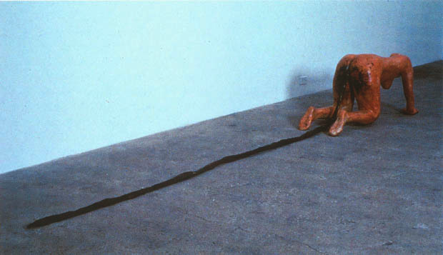
Figure 1, Kiki Smith, Tale 1992
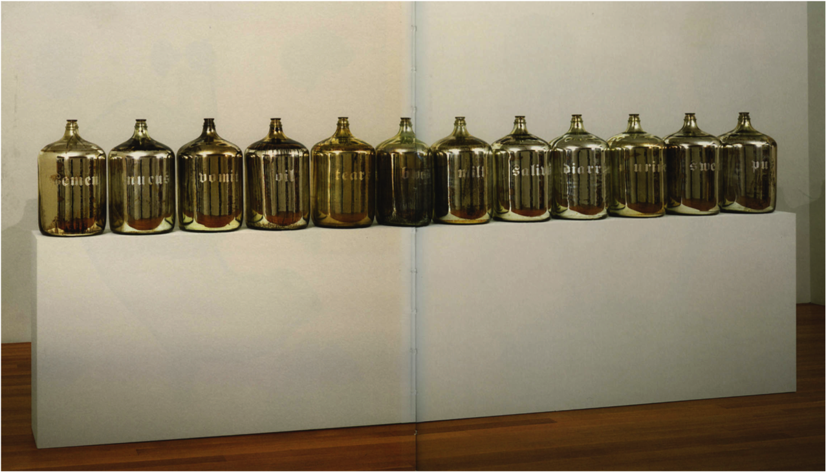
Figure 2, Kiki Smith, Untitled 1986
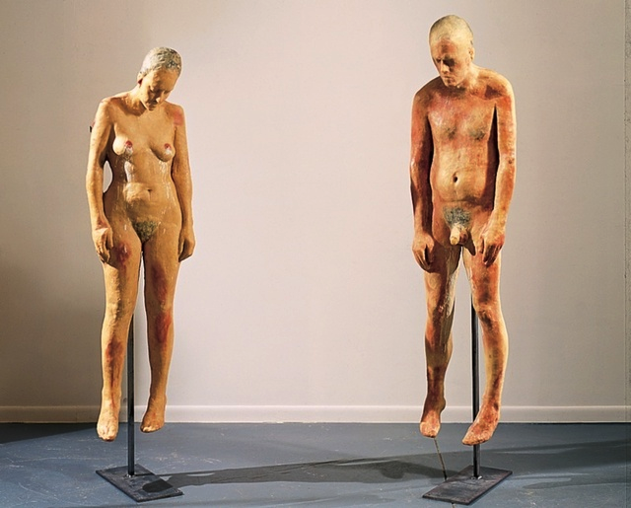
Figure 3, Kiki Smith, Untitled 1990
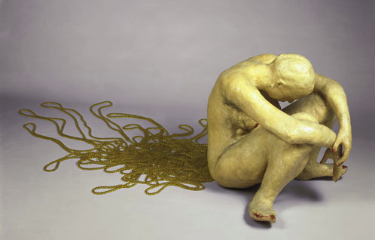
Figure 4, Kiki Smith, Pee Body 1992
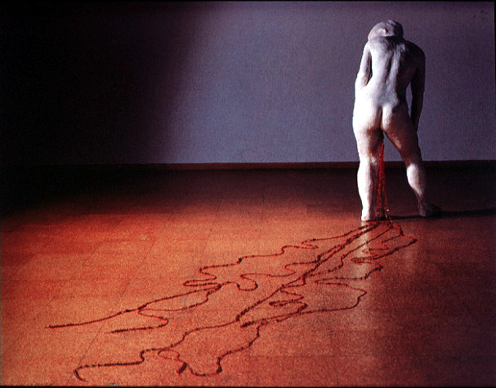
Figure 5, Kiki Smith, Train 1993

